Cyber Security Innovation : Bye Bye "Open Sesame". Hello "GATE" ^_^ !

Introducing An Interception-proof Authentication And Encryption System And Method

Problems with traditional password :

[1] Too weak ?
[2] Too short ?
[3] Need to add special characters ?
[4] Prone to peeking / interception ?
[5] Prone to phishing ?
[6] Prone to dictionary attack ?
[7] Too many restrictions that you can't even remember your own password ?

Weak passwords make systems vulnerable, yet strong passwords make you forget. Is there a way to keep the passwords simple and yet still make the system strong and secure ?!

Yes, there is ! 21st century technology is finally sophisticated enough to fix the weaknesses of traditional passwords.

Introducing a digital security innovation : Graphic Access Tabular Entry [ GATE ], an interception-proof authentication and encryption system and method.

The newly patented GATE system overcomes all of the above weaknesses. Special characters are part of the GATE design. It uses tokens to let user enter user pins from passcode, each token has several symbols, some randomly selected user pins are included in these tokens. It is impossible to tell which symbols in the tokens are valid user pins, which are non-user pins, thereby increasing password strength exponentially. Some user pins might not even appear in the tokens, in that case user can and must enter random tokens in place of those pins, and this uncertainty makes guessing your passcode much harder. Here the word token refers to a group/set of symbols.

With GATE you are not afraid that you are being watched or intercepted when you enter passcodes, the GATE innovative method is designed to be peek-proof and interception-proof.

The intention of this invention is to prevent passcode [ similar to traditional password, but can include symbols ] from being intercepted during the process of entering and transmitting. With the protection of this invention, user will not be afraid of being watched by a hacker while entering the information, because the hacker will not know the passcode. Even after many times of observing/intercepting the user entering the login info, the hacker will still be unable to figure out the passcode.

To find a solution to the problems of traditional password, it’s necessary to get to the underlying causes of the problems, they all come down to one thing : the traditional password is too obvious.

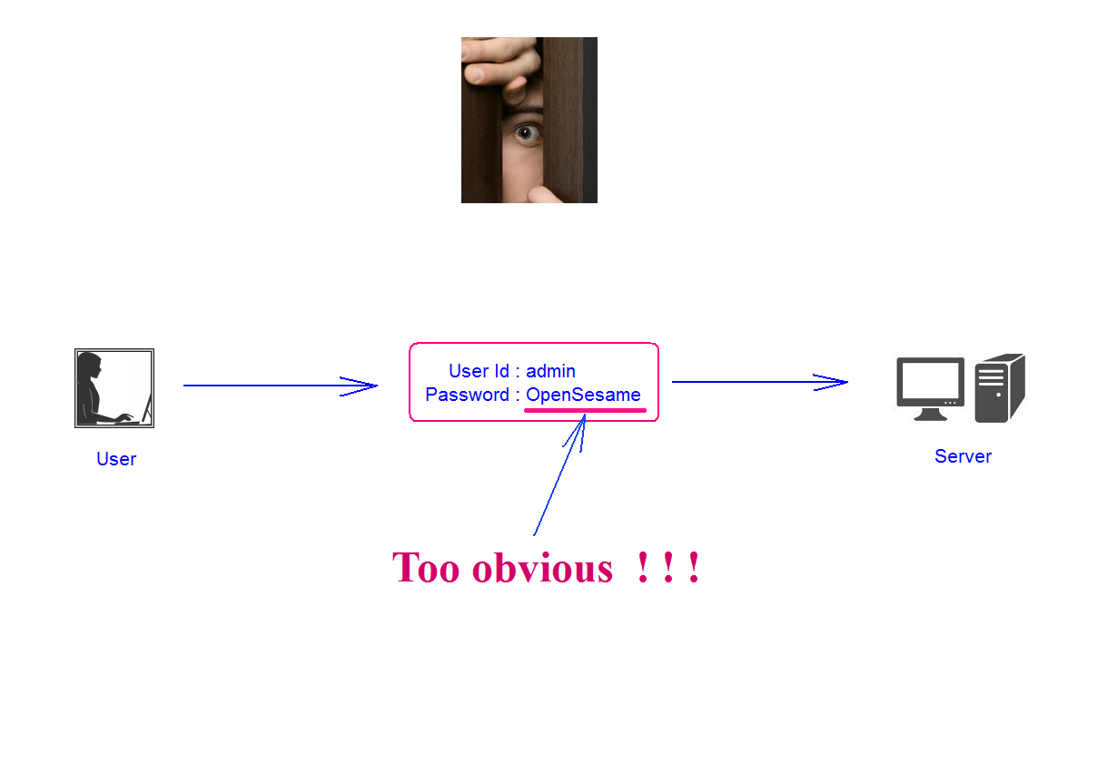
Fig. [1] Traditional_Password_Too_Obvious.PNG

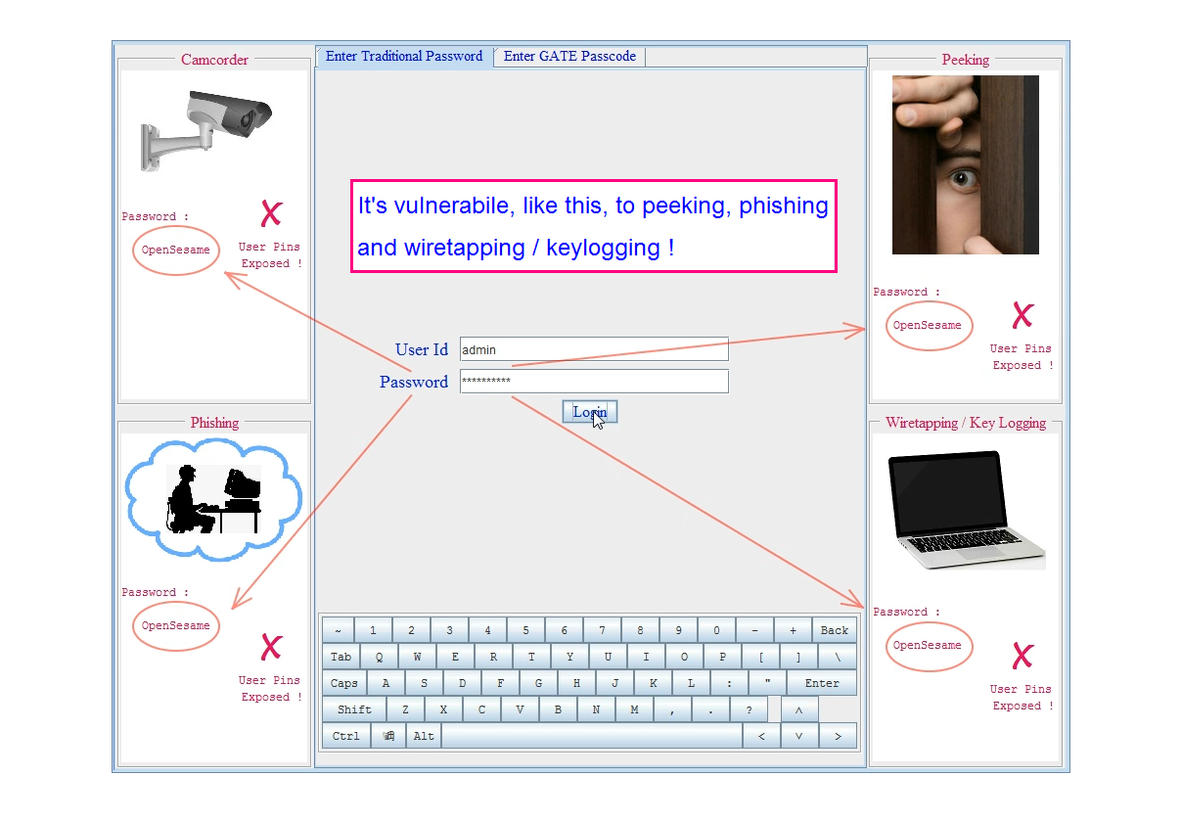
Fig. [2] Password_Exposure.PNG

So to make it not obvious, for each user pin, we can mix it with other symbols to form a token and enter them together as a group. The symbols available for user to select include many different types of signs, so instead of password, let's call it passcode.

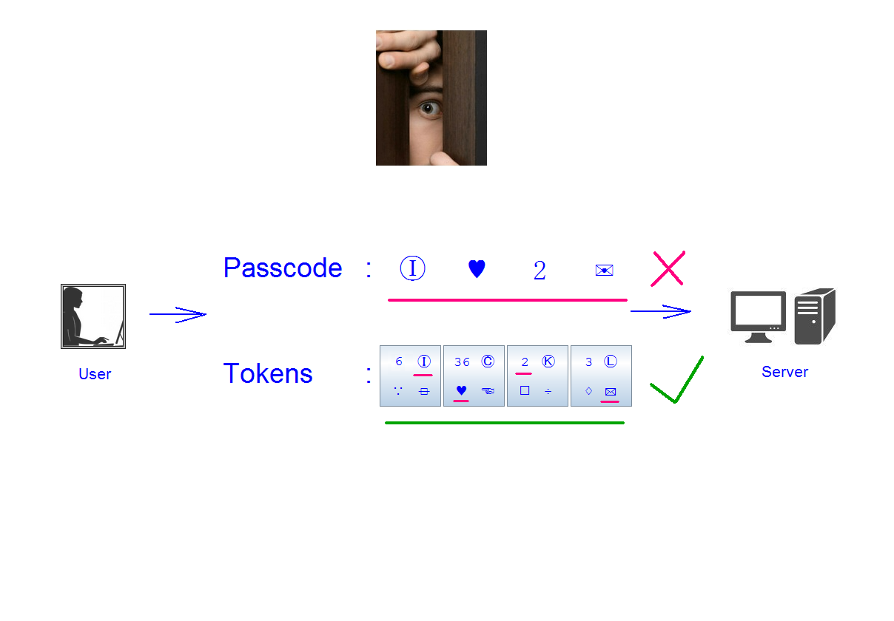
Fig. [3] Mix_Pins_With_Other_Symbols.PNG
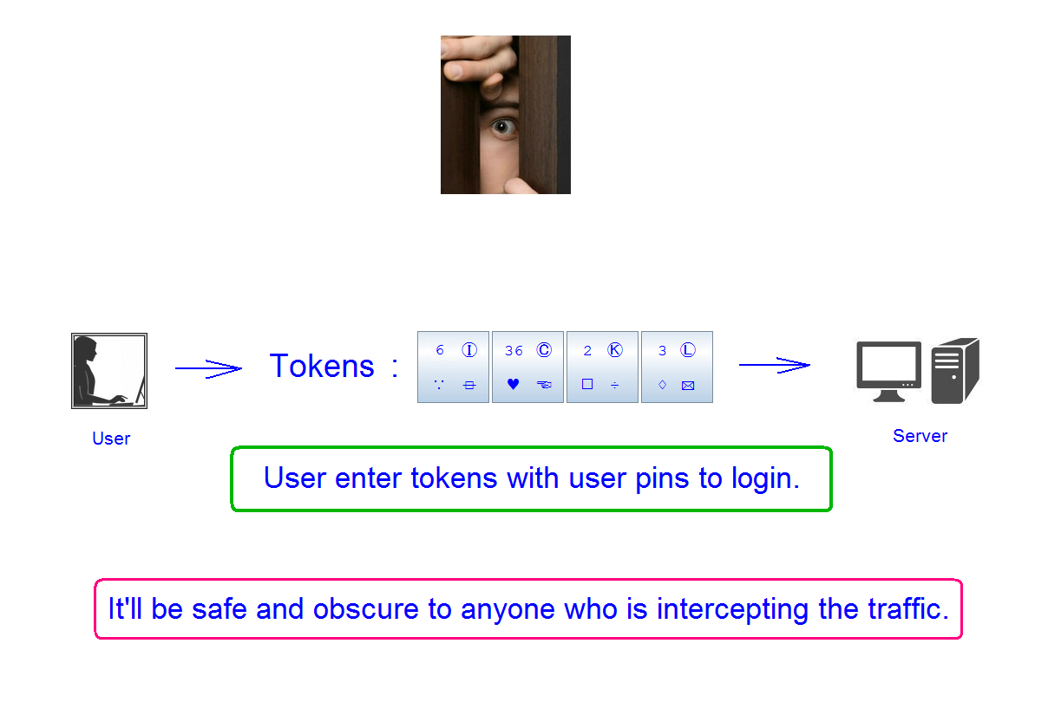
Fig. [4] Enter_Token.PNG

During registration user creates user Id and passcode, user selects user pins from groups of symbols, all the available symbols are grouped into 4 categories, each category of symbols will show up in a unique location in a token, so it will be easier for the user to quickly locate his pins in the tokens.
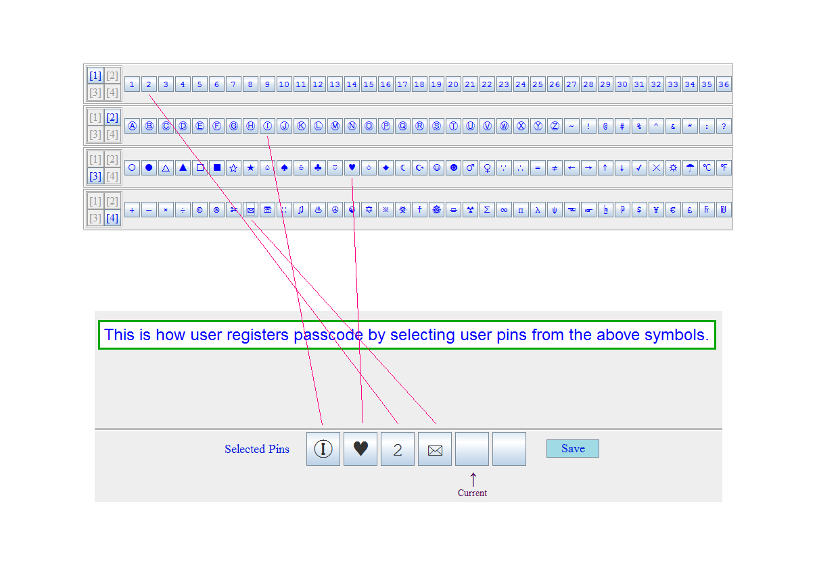
Fig. [5] Registration.PNG

Each time when user enters a user id, the server will find the pins in the user passcode and mix them with other symbols and present them to the user in a tokens table, then the user can select and enter the tokens with user pins to login.
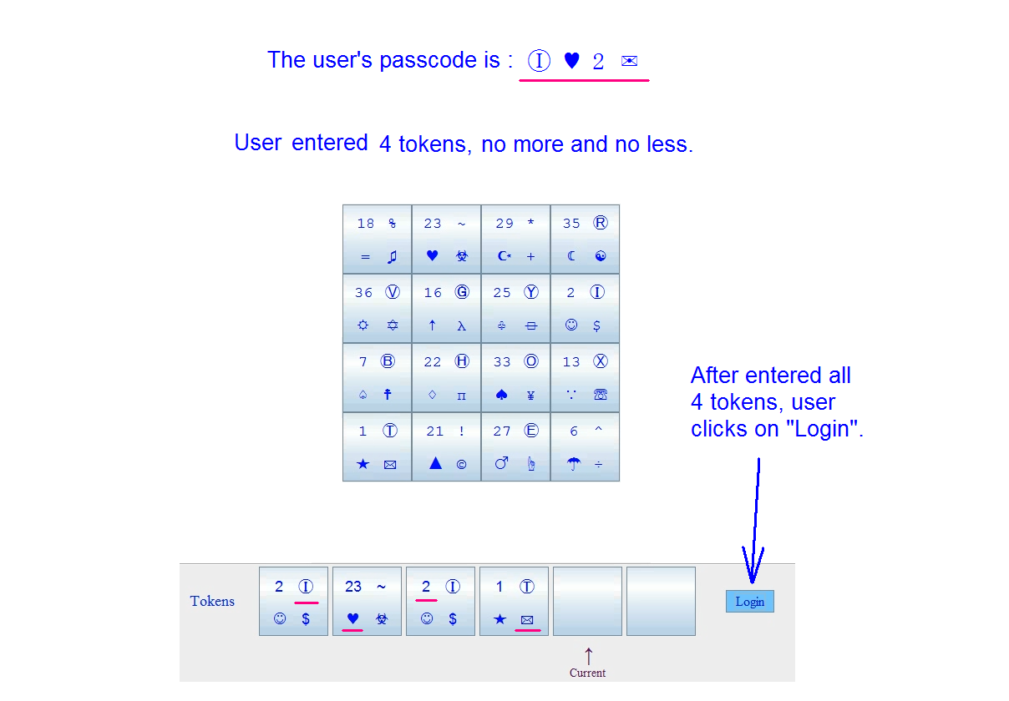
Fig. [6] GATE_Login.PNG

The strength of the passcode doesn't depend on which symbols you enter, but instead is built into the system.

Yet, if the hacker observes the login sessions enough times, he will eventually figure out what each pins is, because if he compares all the first tokens from different login sessions, he can find out that your 1st pin always appears in the 1st token, and your 2nd pins always appears in the 2nd token, and so on.

So in order to avoid that, the server can randomly select several of the user pins to show up in the tokens table, there is no guarantee that all user pins will appear, but at least one user pin will definitely be in the tokens table. When a user pin is not in the tokens table, user can and must select a wildcard [ random ] token to enter that missing pin.
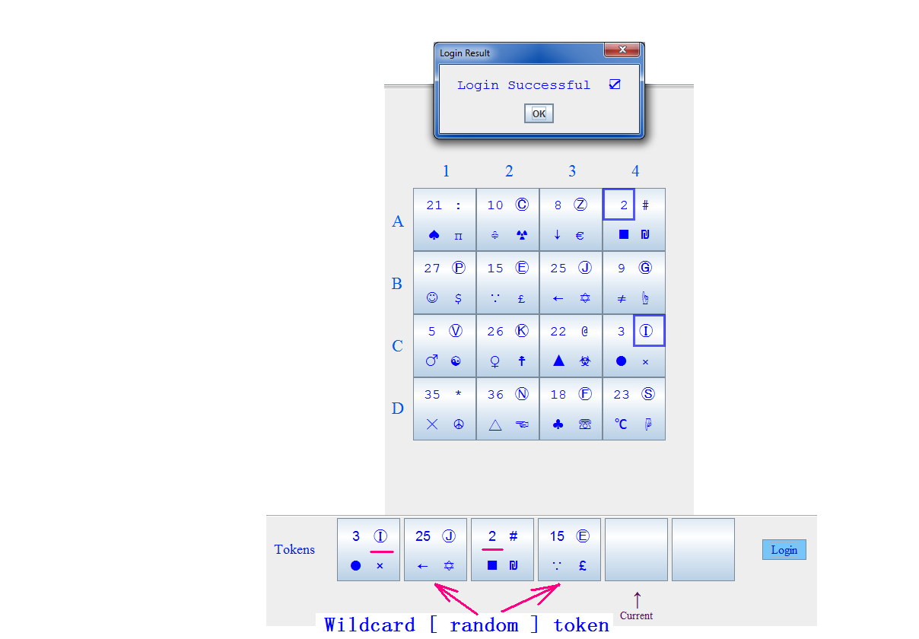
Fig. [7] GATE_Login_With_Wildcard_Token.PNG

The tokens the user enters each time to login will all be different. There is no guarantee, that all user pins will be in the tokens user enter each time when he successfully login, and therefore the user passcode will not be obvious.

So, even if intercepted, the user passcode will not be exposed. It's simple and secure, you no more need the restrictions of lowercase, uppercase, numbers and special characters, they are all part of the design, you can even use something as simple as 1234 and it won't reduce the strength of the passcode.
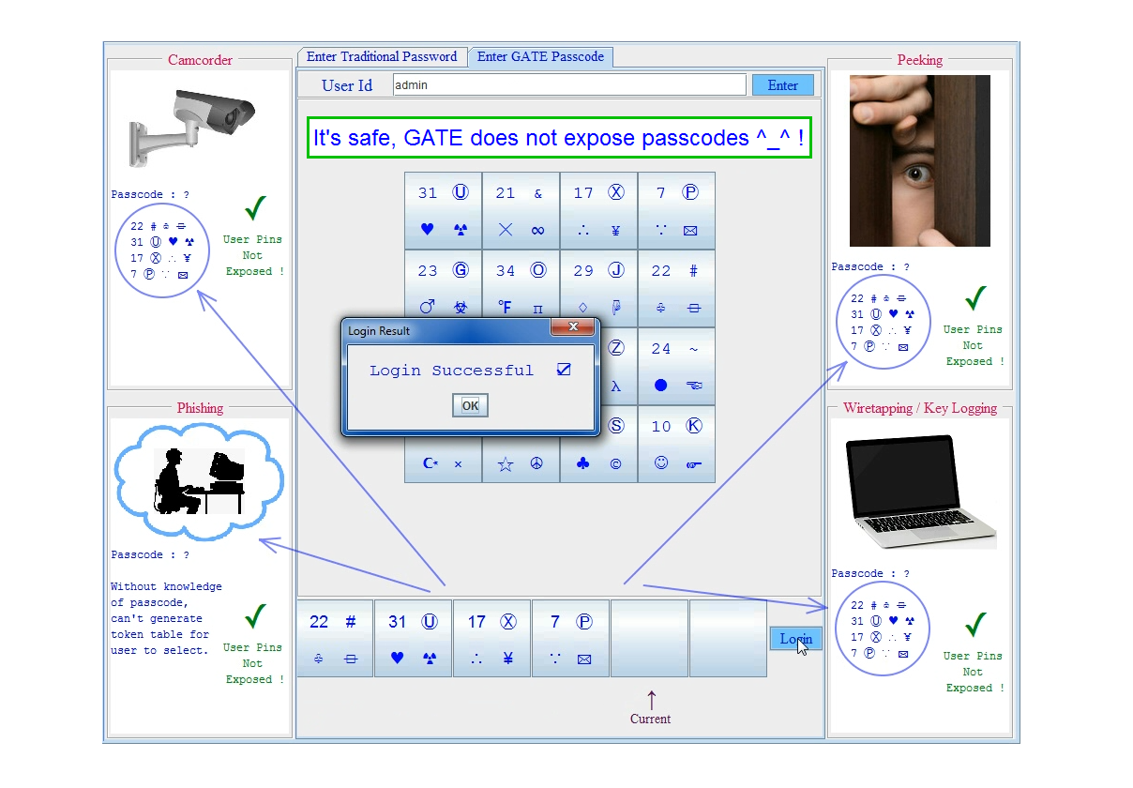
Fig. [8] GATE_Passcode_Not_Exposed.PNG

The available symbols and the size of the tokens table are all adjustable, you can have more symbols if you like, and the tokens table can be 3 x 3, 4 x 4, 5 x 5, or some other configuration, and the number of symbols in each token is also changeable, if there are 4 symbols in each token, it's called GATE_4, if there are 5 symbols in each token, it's called GATE_5.
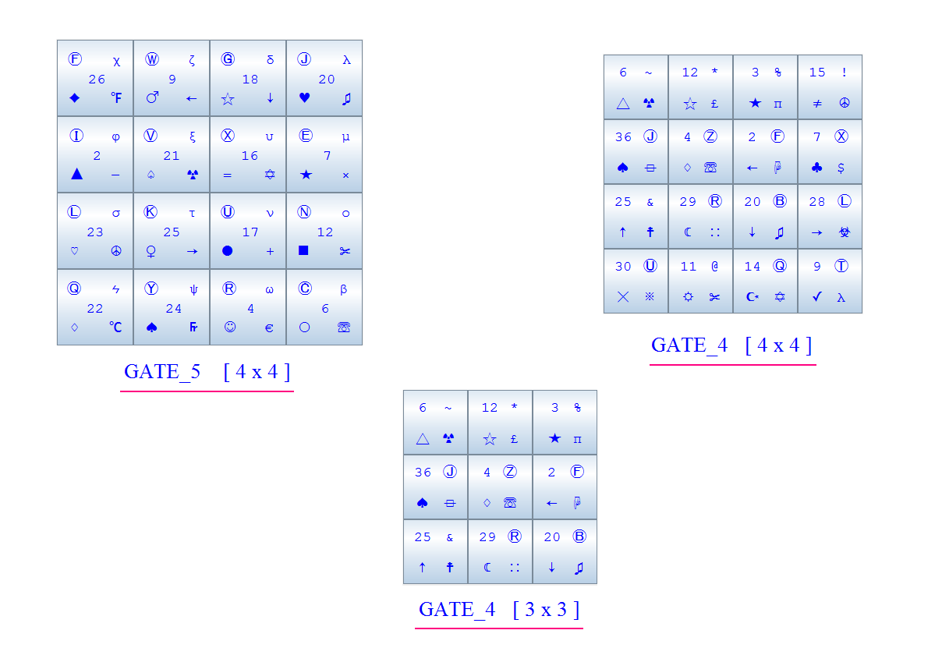
Fig. [9] GATE_Sizes.PNG

Comparing to other authentication systems, GATE has an advantage. Iris scanning and finger printing can only be done between people and machine, while the GATE system can be used in both people to machine and machine to machine authentication. You can use GATE to program machines to authenticate each other.

GATE is not a one-time use passcode, it keeps the same until user changes it.
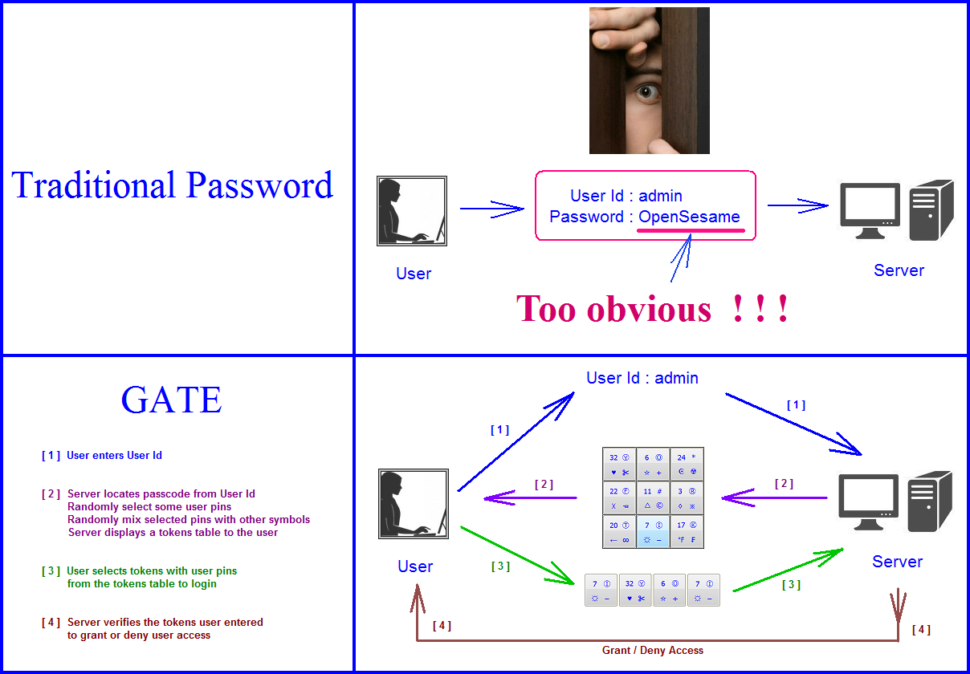
Fig. [10] Traditional_Password_vs_GATE.PNG
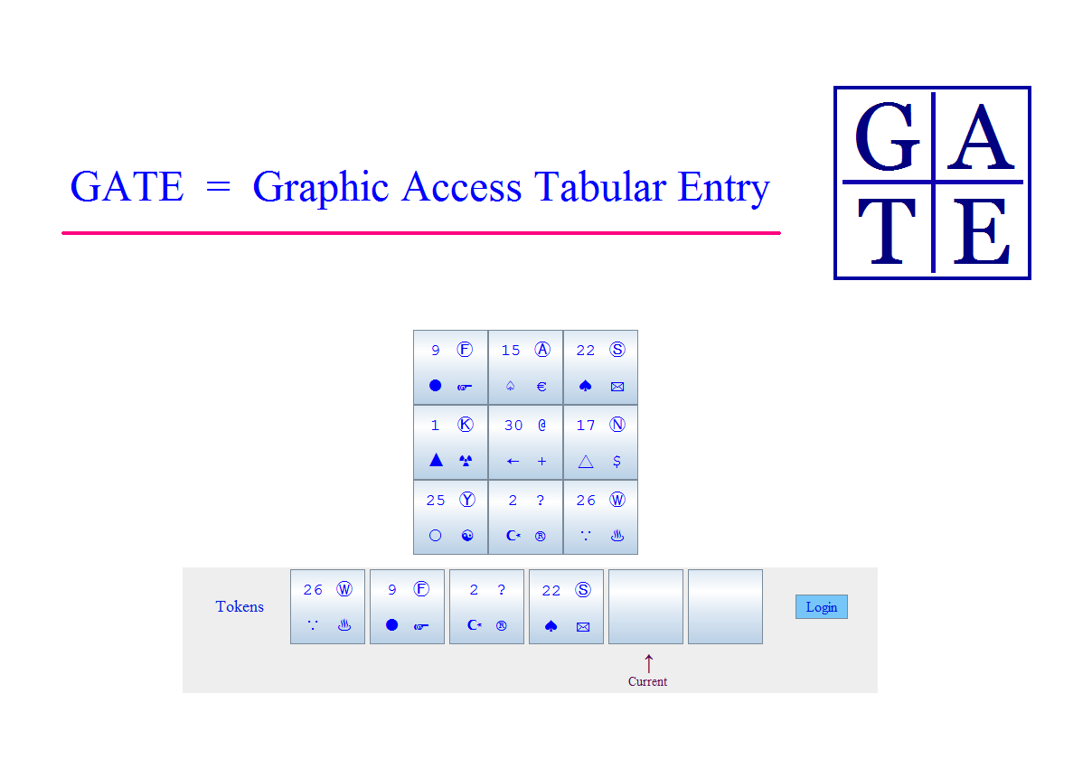
Fig. [11] GATE.PNG

GATE can also be used for information encryption and decryption. Just like authenticating each user, we can use GATE to authenticate each piece of information. We can mix other information elements [ e.g. characters ] with the information elements in your massage and get the encrypted message. Then attach each information element in the encrypted massage with a tokens table and some key tokens, if an information element is from your original message, then the tokens table and the key tokens attached to that information element will authenticate each other, otherwise if an information element is a filler information element, then the tokens table and the key tokens attached to that information element will not authenticate each other, so at the receiver side, we can use the same key that the sender used to decrypt the message and get the original information.

GATE authenticates each piece of information element just like authenticating an individual user, attach valid tokens table and the key tokens to the elements in the original message, and attach invalid tokens table and the key tokens to the filler elements in the message. This is different from all other encryption algorithms.

For instance, in Fig. 12, the original massage is “Abc”, the GATE encryption mixes it with other symbols to get an encrypted message : “.jAdt[bUXcVCcy”, then attach each symbol [ i.e. j , A , d , t, … ] in the encrypted message with a tokens table and some key tokens. In Fig. 12, it is displaying the last symbol in the encrypted message : “y”, as we can see “y” is attached with a tokens table with 16 tokens and 4 key tokens below the table. We can tell “y” is an invalid symbol because the tokens table and the key tokens can't authenticate each other, the reason is : sender passcode is “123”, which means it only has 3 symbols [ pins ], so the key tokens need to have 3 tokens [ one for each pin ], but there are 4 key tokens attached to “y”, so very obvious it won't be authenticated.

The receiver can use this method to authenticate the original information elements “A”, “b” and “c”, and invalidate other non-original [ filler ] information elements. Treat each symbol in the message as a user, if that user has the key tokens that will authenticate, then that user [ symbol ] belong to the original message, if not, that user [ symbol ] belongs to the filler information and will be invalidated [ discarded ] at the receiver side.

The GATE encryption method will generate those tables and key tokens according to the authentication rules, they are well explained in my demo GATE software and you can test it to learn how it works. The “Check” button will check the key tokens against the tokens table to see it they can authenticate each other, in the case of “y” and any other filler characters, it will say “Check Failed”, but since “A”, “b” and the last “c” are part of the original message, they are intentionally attached with tokens table and key token that will validate each other, the “Check” button will display “Check Successful”.
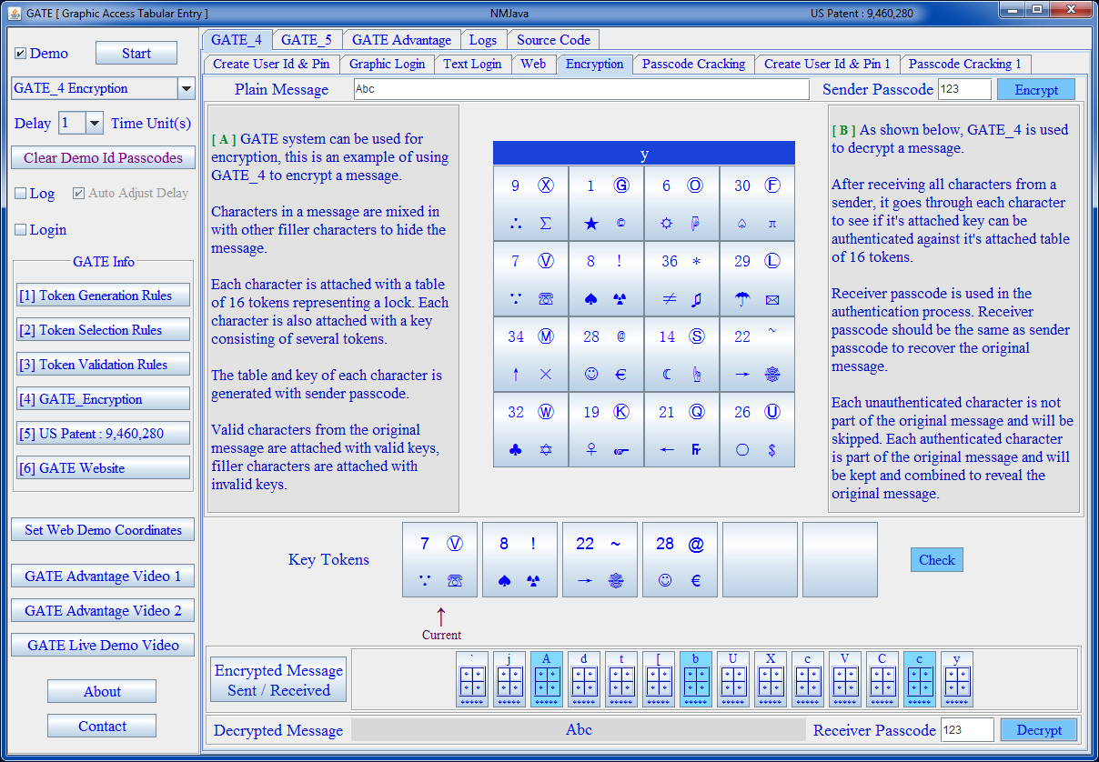
[12] GATE_Demo_Encryption.PNG
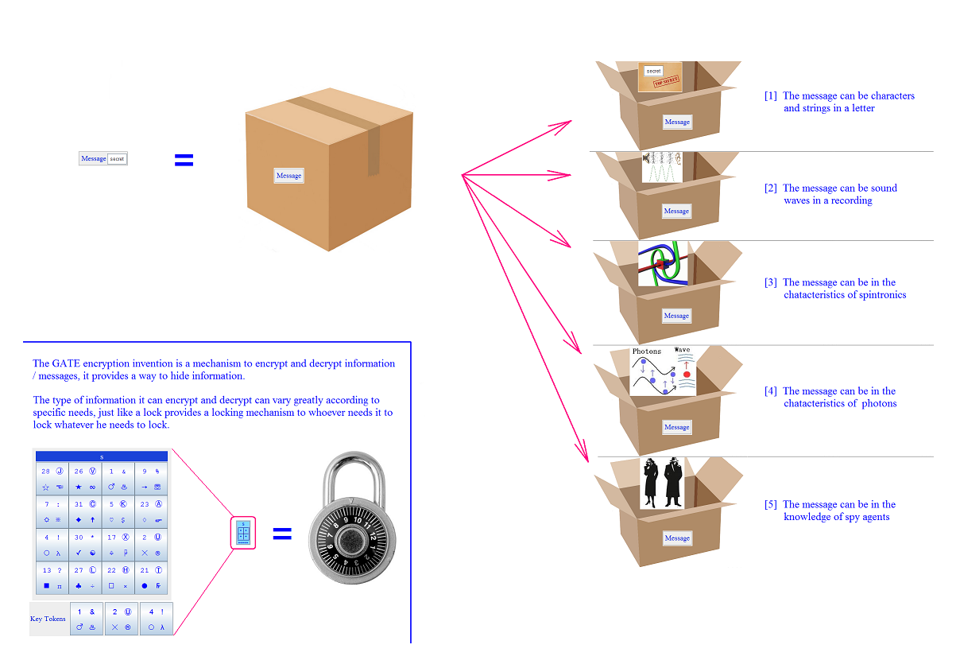
Fig. [13] Message_Encryption.PNG

One more thing about GATE is that it can and will defeat phishing, because in order for a user to enter a passcode, the system needs to get user's pins and mix them with other symbols and present them to the user in a tokens table, since user pins are not known to the phishing site, it can not generate those tokens, and therefore phishing won't work.

Traditional password is like a regular glass, it's not designed to be intercepted, GATE is like a bullet-proof glass, which can withstand multiple shots, GATE can withstand multiple interceptions. GATE is claimed to be “ peek-proof and interception-proof”, here the word “proof” is used in the same sense as the word “proof” in bullet-proof glass and bullet-proof vest, which means it's resistant to peeking and interception.

Traditional password is also like a fixed target, while GATE is like a moving and hard to hit target.

GATE doesn't require users or the system to upload special symbols, it uses Unicode which is in all standard modern computers' OS. It also doesn't need special hardware. GATE can run on all modern devices : mobile phone, ATM, PC, handheld devices as long as it has a graphic display. No special equipment to purchase or install. Basically GATE is a software based mechanism to hide user pins among other symbols and enter them together as a group : think of it as a “hide a needle in a haystack” approach.

To put it in the SIMPLEST way :
If my password is “123”, then when I enter them as : “1” , “2” and “3” you can easily steal my pins.
But what if I enter them as “q&1#” , “%82$” , and “@3!:” [ as groups of symbols ], then how do you know which ones among those symbols are my pins ? That's the essence of GATE ! All the rest are means to achieve this idea.
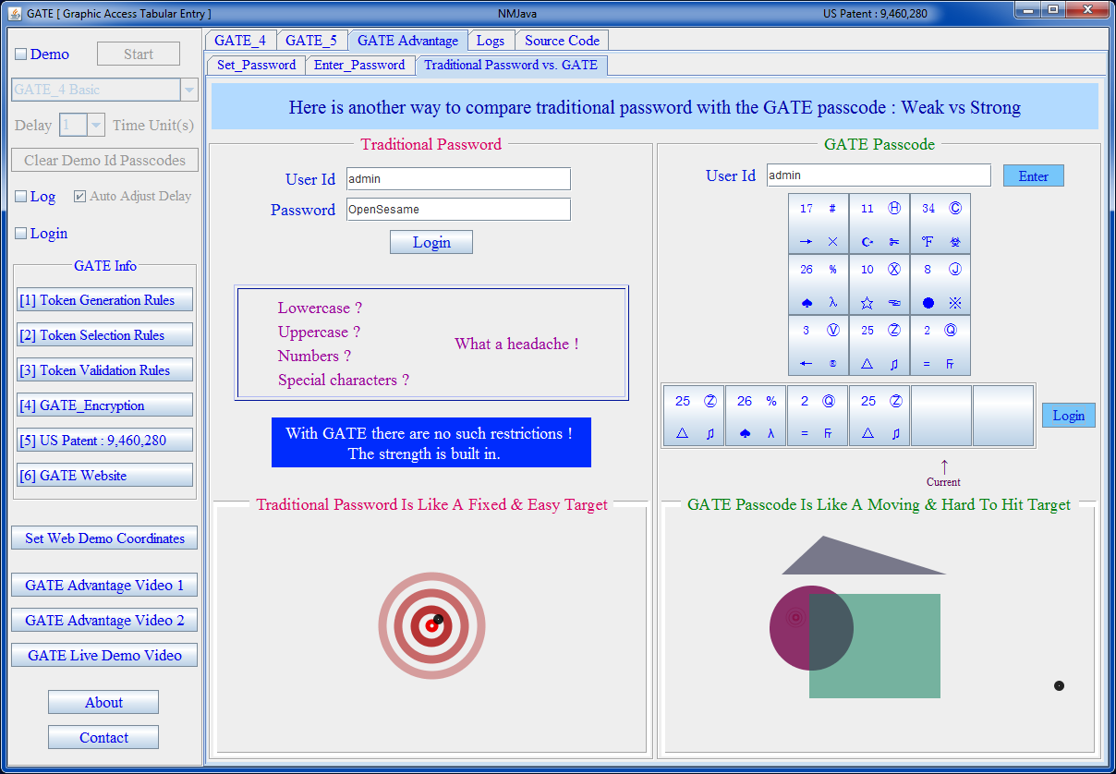
[14] GATE_Compare_To_Password.PNG
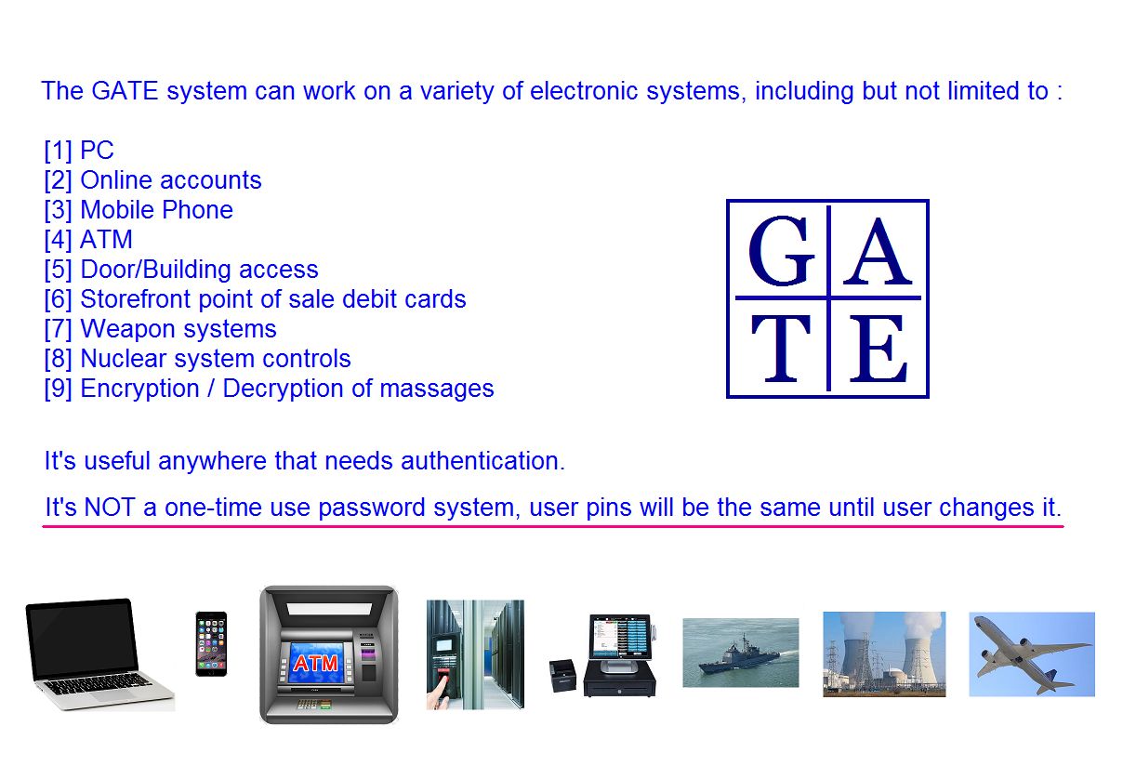
[15] GATE_Vision.PNG
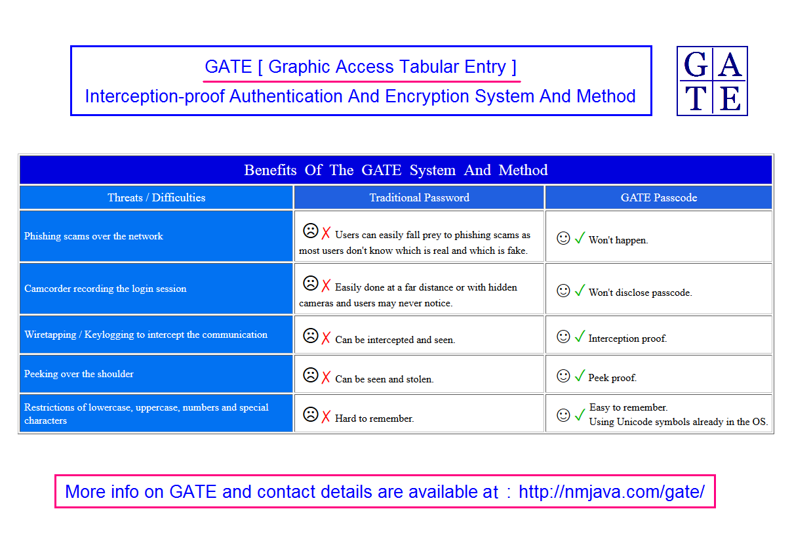
Fig. [16] For_More_Info.PNG

A software engineering manager at Microsoft was interested in GATE, he looked at it and asked about the strength of the system, so I sent him the following data and said :

Alright, here are some real information, let's say you intercepted my traffic 10 times when I successfully logged in, each time it will show you all the symbols in the tokens table, with 16 tokens each has 4 symbols, so that's 16 * 4 = 64 symbols, and the symbols in each of the 4 tokens I entered to successfully login, each token I entered has 4 symbols, I recorded the sessions and here they are, can you tell me what the pins are in my passcode ^_^ ?!

1st time : All_Codes_Vector = [19, Ⓨ, ♦, ☣, 15, Ⓦ, ≠, ₣, 7, ?, ●, +, 18, Ⓗ, ℉, ∑, 30, Ⓖ, ☺, ×, 29, Ⓛ, ☂, ⏛, 8, Ⓠ, ♡, ψ, 13, Ⓥ, ✓, ☝, 32, Ⓕ, ○, ☯, 28, Ⓜ, ♀, π, 26, Ⓣ, △, ♫, 6, ^, =, ☮, 33, Ⓚ, ∵, ☞, 27, Ⓒ, ♥, ÷, 16, #, ☆, ✉, 22, Ⓤ, ∴, ∞]
[ 1 ] [6, ^, =, ☮] [ 2 ] [7, ?, ●, +] [ 3 ] [18, Ⓗ, ℉, ∑] [ 4 ] [28, Ⓜ, ♀, π]

2nd time : All_Codes_Vector = [33, !, =, €, 31, Ⓙ, ∴, ※, 4, *, ♤, ₪, 16, Ⓚ, ♣, ☞, 10, &, ●, ☟, 20, Ⓠ, ★, ♫, 8, ~, ✓, ψ, 23, Ⓣ, ■, ✡, 9, Ⓒ, ♀, ☮, 12, Ⓩ, ☺, +, 3, Ⓐ, ↓, λ, 15, Ⓑ, ♧, ¥, 6, Ⓨ, ≠, ∑, 7, Ⓜ, ☾, ☣, 30, Ⓧ, ○, ☯, 27, Ⓟ, ☓, ☨]
[ 1 ] [23, Ⓣ, ■, ✡] [ 2 ] [4, *, ♤, ₪] [ 3 ] [6, Ⓨ, ≠, ∑] [ 4 ] [4, *, ♤, ₪]

3rd time : All_Codes_Vector = [30, Ⓡ, △, ÷, 19, %, ☾, ₪, 4, Ⓔ, ☻, ✡, 11, Ⓤ, ←, +, 34, Ⓑ, =, £, 2, *, ♥, ☨, 6, Ⓧ, ★, ☸, 17, @, ■, ☯, 1, Ⓨ, ♣, π, 23, #, ☺, ☞, 29, ~, ☆, ☝, 7, Ⓓ, ☂, ψ, 18, !, ≠, ©, 32, Ⓢ, ●, ♨, 5, Ⓞ, ♤, λ, 14, Ⓩ, ♂, −]
[ 1 ] [11, Ⓤ, ←, +] [ 2 ] [23, #, ☺, ☞] [ 3 ] [5, Ⓞ, ♤, λ] [ 4 ] [19, %, ☾, ₪]

4th time : All_Codes_Vector = [9, Ⓒ, ☆, λ, 34, ?, ●, ÷, 21, Ⓕ, ♀, ₣, 33, *, ♢, ✂, 31, @, ↑, ⏛, 10, Ⓤ, ≠, ☏, 28, Ⓡ, ℉, £, 18, Ⓜ, △, ∞, 16, Ⓘ, ♤, ¥, 2, Ⓚ, ♣, $, 29, Ⓑ, ←, ♫, 6, Ⓧ, ✓, ☟, 17, !, ∵, ☜, 27, Ⓩ, ♂, ©, 19, Ⓛ, ■, ☝, 15, Ⓨ, ○, €]
[ 1 ] [34, ?, ●, ÷] [ 2 ] [34, ?, ●, ÷] [ 3 ] [28, Ⓡ, ℉, £] [ 4 ] [21, Ⓕ, ♀, ₣]

5th time : All_Codes_Vector = [18, Ⓤ, ♢, ☝, 13, Ⓠ, ☻, $, 31, ?, ☓, −, 35, *, ≠, ¥, 3, Ⓞ, ●, ☣, 20, ~, ☼, ♨, 22, ^, ♧, £, 19, Ⓔ, ←, ☜, 15, Ⓘ, ☆, ✡, 12, Ⓚ, ☪, ÷, 10, Ⓖ, ↓, ※, 7, %, ♦, ©, 11, Ⓧ, ♠, ☨, 6, #, ★, ☞, 8, Ⓕ, ℃, λ, 17, &, ∴, ☢]
[ 1 ] [11, Ⓧ, ♠, ☨] [ 2 ] [31, ?, ☓, −] [ 3 ] [15, Ⓘ, ☆, ✡] [ 4 ] [20, ~, ☼, ♨]

6th time : All_Codes_Vector = [11, Ⓓ, ☼, ∞, 22, *, ♠, ¥, 27, ?, □, ©, 25, ~, ☾, ☮, 9, Ⓐ, ♤, ⏛, 30, Ⓖ, ♂, +, 6, Ⓚ, ♥, ✡, 4, Ⓗ, ♀, ☞, 7, Ⓧ, ℉, ☯, 12, Ⓣ, ★, ₣, 34, Ⓩ, ←, ☏, 3, Ⓤ, →, ☨, 33, Ⓠ, ☆, ♫, 2, Ⓨ, ∴, ※, 14, Ⓘ, ♡, ☜, 17, ^, ☻, ✉]
[ 1 ] [7, Ⓧ, ℉, ☯] [ 2 ] [27, ?, □, ©] [ 3 ] [7, Ⓧ, ℉, ☯] [ 4 ] [2, Ⓨ, ∴, ※]

7th time : All_Codes_Vector = [33, %, ✓, ✂, 16, ^, ★, ☢, 26, ?, ○, λ, 28, Ⓣ, ∵, ₣, 22, Ⓟ, ●, ∷, 30, Ⓐ, ♠, ☣, 25, Ⓩ, ☆, ✉, 29, ~, →, ¥, 13, Ⓡ, ♀, ☯, 8, Ⓖ, ↑, π, 19, Ⓛ, ≠, ©, 21, Ⓤ, ▲, ⏛, 2, #, ℃, ✡, 31, Ⓝ, ♣, ☮, 18, Ⓥ, ☪, ψ, 5, Ⓦ, ☓, ☜]
[ 1 ] [19, Ⓛ, ≠, ©] [ 2 ] [26, ?, ○, λ] [ 3 ] [33, %, ✓, ✂] [ 4 ] [19, Ⓛ, ≠, ©]

8th time : All_Codes_Vector = [21, ~, ℃, −, 20, Ⓕ, ♂, ☝, 1, @, □, ♫, 32, Ⓡ, ∴, ☯, 4, Ⓗ, ☆, ☏, 17, Ⓝ, ☼, ☮, 26, Ⓠ, ✓, ®, 7, #, ☾, ☢, 12, Ⓤ, ↓, $, 3, Ⓚ, ☂, ©, 31, Ⓐ, ●, ✡, 10, Ⓢ, ☺, ×, 28, ?, ☪, ✂, 11, Ⓔ, ☓, ☣, 5, Ⓜ, ↑, ⏛, 16, ^, ☻, ☟]
[ 1 ] [1, @, □, ♫] [ 2 ] [28, ?, ☪, ✂] [ 3 ] [28, ?, ☪, ✂] [ 4 ] [1, @, □, ♫]

9th time : All_Codes_Vector = [35, Ⓐ, ♣, ※, 13, Ⓓ, ☻, $, 6, ?, ∴, ☨, 25, Ⓝ, △, ☞, 8, Ⓡ, ✓, £, 10, Ⓦ, ♂, −, 22, &, ☂, ☏, 27, Ⓨ, ♀, ®, 34, Ⓕ, ∵, ☸, 7, Ⓔ, ☾, ₣, 4, Ⓙ, =, €, 28, Ⓚ, ♦, ∑, 29, Ⓗ, ★, π, 33, Ⓧ, ←, ☯, 19, Ⓑ, ♥, ×, 17, Ⓟ, ■, ✂]
[ 1 ] [27, Ⓨ, ♀, ®] [ 2 ] [6, ?, ∴, ☨] [ 3 ] [27, Ⓨ, ♀, ®] [ 4 ] [22, &, ☂, ☏]

10th time : All_Codes_Vector = [17, Ⓙ, ♢, ✡, 15, ^, ☓, λ, 31, Ⓔ, ♂, ×, 25, ~, ☾, ☣, 13, Ⓞ, ☻, $, 23, Ⓓ, ∴, +, 26, Ⓕ, ☪, ☢, 21, #, ∵, ☯, 6, Ⓘ, ↑, €, 1, Ⓛ, ♀, ÷, 2, Ⓧ, ☂, ©, 3, Ⓦ, ♣, ☝, 11, Ⓑ, ■, π, 12, Ⓣ, ←, ⏛, 7, Ⓝ, ✓, £, 10, Ⓖ, ≠, ₪]
[ 1 ] [23, Ⓓ, ∴, +] [ 2 ] [7, Ⓝ, ✓, £] [ 3 ] [6, Ⓘ, ↑, €] [ 4 ] [10, Ⓖ, ≠, ₪]

“A study by a US cybersecurity firm based on 100 penetration tests and 450 real-world attacks discovered that stolen credentials offer the best way into enterprise networks.”

“Weak domain user passwords is a root cause of compromise in 66% of cases.”

“The practical upshot of the report is that there should be more focus on guarding against stolen credentials and network segmentation as defenses.”

“Hackers most commonly use stolen credentials, often first obtained through phishing or other social engineering, to break into targeted networks and (eventually) gain access to sensitive resources, sometimes as part of a multi-stage process.”

Source : http://www.theregister.co.uk/2016/08/22/hacker_playbook/

Projected global cost of cyber attacks in 2019 is $2.1 trillion.

I was asked how GATE compares to other authentication systems. While finger printing, iris scanning, Yubikey and RSA tokens depends on you physically own and use something [ whether it's the print on your finger, your iris or key fobs ], and that "something" can be lost, stolen or imitated. But GATE is software based, it depends on the knowledge you have about your passcode, that's the main difference. For GATE, there is no such hardware to purchase/possess, to carry or to be stolen. The passcode file is stored on the server and it should be encrypted. The encryption key is dynamically generated and not stored anywhere. Programmer can use unique and stable info to generate the encryption key, see sample implementation in my GATE demo program.

The table of tokens is generated by an algorithm on the fly. When user enters the user Id, the server loads the user's passcode, and randomly picks some of the user pins [ usually not all ], to mix them with other symbols and present the custom generated table of tokens to the user, and when the same user logs in next time, the server goes through the same process again to pick another random number of pins from user passcode and mix them with another set of randomly selected other symbols and present the tokens to the user in a table, so there is no table stored on the server, and no table uploaded to the server.

Password has been used for thousands of years, in this digital age, the system is full of weaknesses, and it is a leading cause of cyber insecurity, needs to be replaced, and a much better technology is here for the 21st century secure authentication, are you ready for it ?

Traditional passwords are easily intercepted, yet the GATE system is interception-proof, as more organizations move to the new technology, places still using the traditional passwords will stand out to be easy targets, would you like your competitors to take the lead in adopting this easier yet more secure authentication system and leave you behind as easy targets for the hackers ?

Two years ago, I watched a show on PBS called "Rise of the Hackers", it said password is a weak link in cyber security, and since I am a Sr. Java developer, I thought maybe I could come up with a solution, so I tinkered with the idea of "hiding a needle in a haystack" and wrote a program to do that for password, now it has become a reality.

A utility patent has just been granted for this breakthrough technology. The GATE system and method will offer you better digital security.

More details and FAQs are on my website : http://nmjava.com/gate

There are several demo videos on the top of the web page above. The short versions last around 7 min., the long version lasts 13 + 10 [reference movie clips] min., which is much more fun to watch. Get a drink and some snacks, then kick back and enjoy the show, it's as informative as entertaining, I call it info-tainment ^_^ ! I prefer the long version. I promise you will laugh at it !

There are some music in the videos, they are generated by my Java AI music program, I haven't changed a single note, 100% computer generated. More AI music is available in Google Play and BandCamp [ by NMJava ].

A simple GATE demo program [in exe format ] is available FREE on the site. More complex/complete versions of the GATE programs are available for purchase.

Your feedback is welcome, you can contact me from my web site.

Any leads for organizations that are interested in licensing the GATE system are appreciated. Contact me if anyone is interested in commission based marketing & sales.

Questions & Answers :

1. Is GATE something that is in the market right now or just being realized ?
GATE is coming to the market, and available now if you are interested. You can get it in the following formats :
[1] Sample software -- different versions with different levels of functionality and pricing on the GATE web site : nmjava.com/gate
[2] Licensing -- contact for details

2. In the sentence, "The intention of this invention is to prevent passcode [ similar to traditional password, but can include symbols ]" does the destination computer have knowledge or know how to interpret these symbols ?
Only the server that runs GATE has knowledge of the symbols and knows how to interpret them, the client that user logs in is only functioning as input/output device, it knows nothing about how to interpret these symbols, it just passes the info between the server and the user.

3. About the token, is it a physical token that you have to carry around ?
No, it's not a physical entity you carry around. I'm just borrowing the word "token" to refer to a groups of symbols that are presented to the user, you can easily use other words to mean the same concept : symbols group, or symbol set. The purpose of using a group of symbols is to hide each user pin among other symbols, so the user pin is not obvious to a hacker/observer.

4. When using GATE, do you remember letters or symbols ?
Yes, of course, user has to remember the user Id and pins in the passcode. This is the same as traditional password, you need to know what your user Id is and what the pins are in your password. What's different between GATE and traditional password is : instead of entering one pin at a time [ which is easily stolen by a hacker/observer ], GATE enters a group of symbols at a time for each user pin, the user pin is mixed in the symbols, so it becomes obscure. And only the user and the server know whether the tokens entered are valid or not.

5. What would it take to implement this technology, both in terms of equipment and money ?
[1] Equipment : no special requirement. Any modern device will be able to run GATE, assuming the following :
[A] A graphic display that can show images [ touch screen will be better, but not necessary ]
[B] A mouse [ can be skipped if the display is touch screen ] to point on the display and click to enter info.
[2] Money : can get you some or all of the following if you desire :
[A] Training for the GATE system
[B] Sample GATE software to show you how to implement the concept, it's written in Java, different versions/complexity of the software are available with or without [ if you only want to see how it works ] source code at different prices. See web page for details.
[C] Licensing for the patented GATE system
Contact for details.

6. "You can use GATE to program machines to authenticate each other", can the author explain this further ?
With traditional password, you can use machine A to log into machine B, as long as machine A knows the password, this is the same with GATE, machine A can log into machine B, as long as machine A knows the GATE passcode on machine B. The reason I'm saying this is : some authentication methods only works between human and machine : finger printing & iris scanning, they can only authenticate human, they can't be used to authenticate a machine. But GATE, like traditional passwords, can be used to authenticate both human and machine.

7. "GATE can also be used for information encryption and decryption", what encryption algorithm is used ?
It uses the GATE encryption algorithm, it mixes information elements with misinformation elements, then attach valid tokens table and key tokens to the information elements and invalid tokens table and key tokens to the misinformation elements, and sent them out, on the receiver side, authenticate each set of information by checking the attached tokens table and key tokens, then get rid of the misinformation and get the original information. This method is explained in the GATE video : https://www.youtube.com/watch?v=518p2cIbynY

8. Any hashing for the passcode file ?
The GATE passcode file is encrypted, not hashed, so the GATE app running on the server can decrypt and read it back to get the user pins, then mix them with other symbols to present them to the user as tokens table. Programmers can select any reliable encryption method they choose, the encryption key can be dynamically generated and it is not saved anywhere so no one can steal it. The encryption key can be generated by mix some of the following unique and yet stable info : server Id, CPU property, motherboard property, the GATE app Id on the server, hard drive serial number or some other property that is not saved in a file or db, but the GATE app can get by making a call to the system. That way a hacker won't be able to get the key from a file or db, and this will make the encryption key safe from being stolen. In case the info gets changed because of a system change [ CPU, motherboard, hard drive failure and need to replace them with a new one and therefore the info used to generate the encryption key needs to change ], then users need to reset their passcodes.

I'm forced to update my passwords every 3,4 months with the current password system, with the GATE system, if such changes do happen, just treat it as a forced password update for the sake of safety, shouldn't be too much of an issue, because people are already doing it now with the traditional password system anyway. So the main point is to select some unique [ different from machine to machine, and different from one GATE app to another ] and stable [ so it keeps the same for a long time, therefore users don't have to reset their passcodes too often, assuming you don't change your CPU/motherboard every month ]. The programmer can combine some of the selected properties and get a hashed string, then use that as the encryption key. Therefore this key will be unique when it's running on each machine, even the programmer will not know what the key will be when the GATE runs on a production machine, because when the app runs on development machine, it uses the info from the development environment, but when it's running on a production machine, the info from that environment will be different. Dynamic, unique and stable are the 3 key words here. Sample implementation is in my demo code.
================================================================================================================

Don't bring a stick [ traditional password ]

or a knife [ biometric ]

to a gun fight [ 21st century cyber challenge ].

Bring a machine gun [ GATE ] ^_^ !



Author Bio :

I've been a Sr. Java developer for many years, got my MS in computer science from Indiana University in Bloomington IN. I'm originally from Shanghai China, got my undergraduate education in Shanghai University Of Engineering Science.

Learned Java on my own and have been doing a lot of programming on the subjects that interest me, one of them is computer music, so I wrote an AI music program to automatically generate music, it's like a volcano, automatically produce hundreds/thousands of tunes and I just pick the best ones [ like diamonds ] to compile them into several albums. If you are interested, you can find them on Google Play and Bandcamp [ by NMJava ].

My other interests include martial art and Latin dancing, it's a good way to work out with music, guys like me sit in front of computers for too long. Given opportunity I'd like to spend time on AI, training computers to learn how to solve problems.

Looking back, the invention of GATE is like an accident, one night, I was watching TV, it happens to be showing "Rise of the Hackers" on PBS, and I happened to have some spare time, so I tell myself, this is a problem that I can solve, turn something obvious into obscure, so step by step I tinkered with this idea and put it into programming, finally it became reality. So, one down, N more to go ^_* !

Frank

